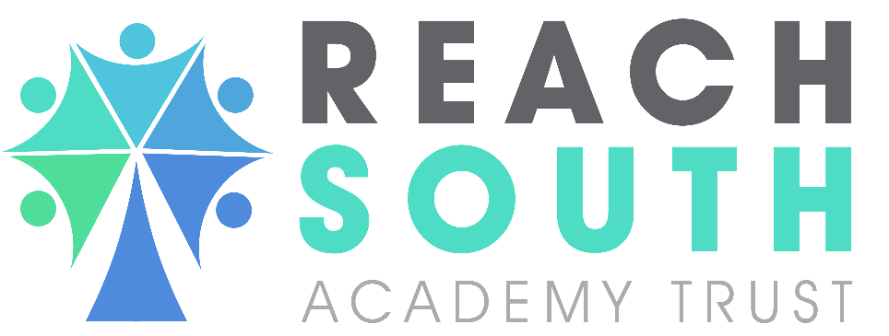
Marlborough Primary Academy

SAFEGUARDING AND CHILD PROTECTION POLICY & PROCEDURES

Approval Date | August 2025
Policy Owner | Deputy CEO
Adopted by Trust Board | August 2025
Review Date | September 2026

CONTENTS

Section | Description | Page No.
1 | Key Academy Contacts | 4
2 | Key External Contacts | 5
3 | Safeguarding Statement | 7
4 | Legislation, Terminology and Key Documents | 8
5 | Roles and Responsibilities: | 9
6 | DSL | 10
7 | Headteacher | 10
8 | Governing Body | 11
9 | Mandatory Reading | 11
10 | Board of Trustees | 11
11 | Safeguarding Duties and Procedures: | 12
12 | Training | 12
13 | Taking Action | 13
14 | CYP Procedure and Process | 14
15 | Female Genital Mutilation (FGM), Preventing Radicalisation and Mental Health | 15
16 | Alternative Provision (AP) | 16
17 | Out-of-School Settings | 16
18 | Attendance | 17
19 | Risk Assessment | 17
20 | Supporting Disclosures: | 18
21 | Communication with Parents/Carers | 18
22 | Safeguarding Interventions Including Early Help | 19
23 | Record Keeping | 19
24 | Confidentiality and Information Sharing | 20
25 | Child-on-Child Abuse: | 21
26 | Sexual Violence, Sexual Harassment and Harmful Sexual Behaviour | 21
27 | Online Safety: | 22
28 | Use of Mobile Technology | 22
29 | Safer Recruitment, Allegations Against Staff and Low-Level Concerns | 23
30 | Site Security | 24
31 | Additional Reporting | 24
32 | Policy History | 25
Appendix 1 | Abuse, Neglect and Exploitation (extracted from Keeping Children Safe in Education 2024) | 26
Appendix 2  Appendix 3 | Additional Specific Safeguarding Issues  Safeguarding Triage | 27  31

Key Academy Contacts
Strategic Designated Safeguarding Lead (DSL)  Marlborough Primary Academy | Stephanie Macdonald  Headteacher  Email: steph.macdonald@highstreetacademy.org  Telephone number (term time): 01752 567681
Operational Designated Safeguarding Lead (DSL)  Marlborough Primary Academy | Andrew Dore  DSL, Deputy Headteacher  Email: andrew.dore@marloroughacademy.org  Telephone number (term time): 01752 567681
Safeguarding officers (Level 3 Trained staff) | Jenny Cleverley  Email: jennifer.cleverley@marlboroughacademy.org  Telephone number (term time): 01752 567681
Chair of Governors | Nick Buckland
Nominated Safeguarding and Child Protection Governor | Nick Buckland
The Designated Teacher (DT) | Andrew Dore  Email: andrew.dore@marlboroughacademy.org  Telephone number (term time): 01752 567681
Attendance Lead / Attendance Champion | Steph Macdonald  Steph.macdonald@marlboroughacademy.org

2 Key external contacts
Local Authority Designated Officer(s) (LADO) | Sally Parma (LADO)  Telephone: 01752 304389  Email: lado@plymouth.gov.uk
Plymouth Children's Social Care | Telephone number: 01752 668000 option 1  Email: mash@plymouth.gov.uk  Out of hours emergency:01752 346984  Professionals’ advice number: 01752 304339
Plymouth Safeguarding Children Partnership | plymouthscb.co.uk
FGM reporting - non-emergency police contact number | 101
Devonport Policing team | Chapel Street Police Station, Devonport Plymouth  Devon, PL1 4DW
Prevent partners and advice about extremism | Prevent.referrals@devonandcornwall.pnn.police.uk  Non-emergency DfE advice 020 7340 7264  counter-extremism@education.gsi.gov.uk
Plymouth Virtual School | Kate Richardson  kate.richardson@plymouth.gov.uk
UK Safer Internet Centre | 0344 381 4772  helpline@saferinternet.org.uk
NSPCC whistleblowing helpline | Weston House  42 Curtain Road  London  EC2A 3NH  Telephone: 0800 028 0285  Email: help@nspcc.org.uk  https://www.nspcc.org.uk/what-is-child-abuse/types-of-abuse/
Reporting serious wrongdoing to the Education and Skills Funding Agency | For further guidance please see:  https://www.gov.uk/guidance/how-esfa-handles-whistleblowing-disclosures
Report Abuse in Education helpline | A dedicated helpline for children and young people who have experienced abuse at school, and for worried adults and professionals that need support and guidance, including for non-recent abuse. 0800 136 663 or email help@nspcc.org.uk

3 Safeguarding Statement

Safeguarding is our number one priority; the golden thread that runs through Reach South Academy Trust. We are committed to creating a safe, respectful, and inclusive environment where our children and adults feel protected, valued, and confident to speak up. Our child-centred approach ensures that decisions are made in the best interests of the child, with a focus on removing barriers, raising aspirations, and improving outcomes. We embed a whole school approach to safeguarding through a culture of professional curiosity and “it could happen here”.

At Reach South Academy Trust, safeguarding means protecting our Children and Young People (CYP) from harm (including inside and outside of school, home and online), so they can thrive in a safe, supportive environment. We prioritise early intervention and staff will act promptly and appropriately to concerns.

At Marlborough Primary Academy this means prioritising and understanding our school context, local context and the needs of our CYP and families. [This includes an understanding of the different local authorities we work alongside, their policies, practices and safeguarding procedures/referral processes. We also have a responsibility to contextualise safeguarding based around the individual child and their diagnosed SEND. This may mean supporting a child in a variety of different formats in order to ensure their safeguarding needs are met e.g. communication method and / or preferred adults.]
The purpose of this policy is to provide all stakeholders including employees, volunteers, governors, trustees and visitors with the framework they need to protect CYP and keep them safe at Reach South Academy Trust.
This policy and our safeguarding responsibilities apply to all Academy activities (before, during and after school), onsite, off-site and out of school hours, including when a child attends an Alternative Provision (AP) and when our facilities are used by another provider.
This policy is kept up to date, regularly reviewed and is published on the Academy website, a hard copy is available at reception and on request. This policy can be made available in large print or other accessible format if required.
This policy is agreed and acknowledged from the following key personnel, who will ensure the policy is implemented by all staff:
Reach South Academy Trust’s Head of Safeguarding: Mrs Sharna Denver

Marlborough Primary Academy Headteacher: Mrs Stephanie Macdonald
Strategic Designated Safeguarding Lead (DSL)

Marlborough Primary Academy Operational Designated Safeguarding Lead (DSL): Mr. Andrew Dore

Marlborough Primary Academy: Safeguarding Governor: Nick Buckland-Interim

Marlborough Primary Academy the Chair of Governors: Nick Buckland

Legislation, Terminology and Key Documents
  - This policy has been considered and been prepared in line with current legislation (and any amendment to the same) including but not limited to:
    - The statutory guidance ‘Working Together to Safeguard Children’ (2023) and ‘Keeping Children Safe in Education’ (KCSIE) (2025).
    - The Early Years Foundation Statutory Framework.
    - Statutory guidance on the Prevent duty and Female Genital Mutilation (FGM).
    - The Human Rights Act 1998, The Children Act 1989 (and 2004 amendment), the Equality Act 2010, Public Sector Equality Duty, Charities Act 2011, Data Protection Act 2018 and UK General Data Protection Regulation (UK GDPR).
    - The Academy’s Local Safeguarding Children’s Partnership Guidance, Local Authority policies, procedures and threshold guidance.
    - This policy is an overarching policy and in addition to the above, should be read in conjunction with Reach South Academy Trust’s suite of policies Reach South Academy Trust - Policies and Marlborough Primary Academy specific policies.
  - Child/ren includes everyone under the age of 18 years old. We will use the term ‘Children and Young People (CYP)’ in this policy, when referring to our pupils.
  - Child protection refers to the processes undertaken to protect children who have been identified as suffering or being at risk of suffering significant harm (Section 47).
  - Children in Need refers to a child who is unlikely to achieve or maintain a reasonable level of health and development, or whose health and development is likely to be significantly or further impaired, without the provision of services, or a child who is disabled. Local authorities are required to provide services for children in need for the purposes of safeguarding and promoting their welfare. (Section 17).
  - References to the Proprietor in this policy are references to Reach South, the Academy Trust. In all academy trusts, the Board of Trustees is responsible for the safeguarding arrangements of its school/s. In a multi-academy trust, the Board of Trustees may choose to delegate certain safeguarding functions to a local governing body under a scheme of governance. The Proprietor cannot delegate its legal responsibilities for safeguarding to a local governing body. In this policy, references to Board of Trustees are references to the Proprietor.
  - References to Parent or Parents means the natural or adoptive Parents of the pupil (irrespective of whether they are or have ever been married, with whom the pupil lives, or whether they have contact with the pupil) as well as any person who is not the natural or adoptive Parent of the pupil, but who has care of, or Parental responsibility for, the pupil (e.g. foster carer / legal guardian).
  - References to Children's Social Care includes, depending on the context, the team based in the local authority where the Academy is located and, where appropriate, the team based in the local authority where the child is a resident.
  - References to harmful sexual behaviour in this policy refer to the DfE's definition: sexual behaviours expressed by CYP under the age of 18 years old that are developmentally inappropriate, may be harmful towards self or others, or abusive towards another child, young person or adult.
  - References to staff includes all those who work for or on behalf of the Proprietor, regardless of their employment status, including Contractors, Supply Staff, Volunteers, Trustees and Governors unless otherwise indicated.
  - Acronyms used in this policy:
    - AP – Alternative Provision
    - DSL – Designated Safeguarding Lead
    - DDSL – Deputy Designated Safeguarding Lead
    - CSC – Children’s Social Care
    - CSE – Child Sexual Exploitation
    - CCE – Child Criminal Exploitation
    - CYP – Children and Young People
    - FGM – Female Genital Mutilation
    - KCSIE – Keeping Children Safe in Education
    - LA – Local Authority
    - LADO – Local Authority Designated Officer
    - SEND – Special Educational Needs and Disability
    - SLT – Senior Leadership Team

Roles and Responsibilities:
  - All Staff (including Governors) are required to:
    - Recognise safeguarding is everyone’s responsibility—not just those working directly with CYP.
    - View all school activities, including behaviour and attendance, through a safeguarding lens.
    - Ensure that the welfare of the child is paramount; CYP must feel listened to, valued, and safe, recognising that some CYP have an increased risk of abuse and additional barriers and vulnerabilities including SEND, those who currently or have previously had social services involvement and who require mental health support.
    - Foster a safe, welcoming environment that supports CYP’s confidence and learning.
    - All staff should know who the Headteacher, DSL, Safeguarding Governor, and Chair of Governors are.
    - Contribute to a safe environment where CYP can thrive and achieve their best outcomes.
    - Promote protective factors such as self-esteem, confidence, supportive friendships, and trusted adults.
    - Embed safeguarding and preventative education throughout the curriculum.
    - Respond in line with a zero tolerance to any form of child-on-child abuse, sexual violence/harassment, and discrimination.
    - Be aware of signs of abuse, neglect, exploitation, and other safeguarding risks, including persistent or unexplained absences.
    - Take timely action on safeguarding concerns, in line with legislation and LA procedures, ensuring high quality record-keeping, and effective with relevant agencies.
    - Identify and support those that may benefit from Early Help.
    - Assess and mitigate risks of radicalisation and extremism.
    - Have a reflective approach to improving and incorporating best practice.

DSL
  - As a senior leader, the DSL holds lead responsibility for all aspects of safeguarding and child protection, including online safety and monitoring systems. Their full responsibilities are outlined in KCSIE and in their job description. This responsibility cannot be delegated; however, tasks may be assigned to others, with ultimate responsibility remaining with the DSL.
  - Ensures:
  - Compliance with current KCSIE and all statutory safeguarding duties.
  - A whole-school safeguarding culture embedded in systems and practice.
  - Staff are supported, confident, and effective in their safeguarding duties.
  - Children and Young People (CYP) feel safe, protected, and listened to.
  - Liaises regularly with the Headteacher, especially regarding police investigations and statutory support (e.g. Appropriate Adult and Police and Criminal Evidence Act 1984 (PACE) Code 2019).
  - Ensures there is a staff member responsible for Attendance, Looked After Children and Mental Health and Wellbeing (also acts as Senior Mental Health Lead). The DSL will liaise with this member of staff when there are safeguarding concerns.
  - Completes an annual safeguarding self-assessment audit.
  - Works closely with Deputy DSL(s) (DDSL), who act in the DSL’s absence. A thorough training programme is in place, including a robust induction in line with KCSIE, covering key policies and safeguarding systems used in the school.
  - Collaborates with the Trust’s Head of Safeguarding.

Headteacher
  - Overall management of the school, including concerns or allegations involving staff.
  - Ensuring policies are understood and followed.
  - In conjunction with the DSL, regular reporting of safeguarding trends, lessons learnt, and strengths are shared with key stakeholders, including Governors and the Trust Head of Safeguarding.
  - In conjunction with the Office Manager and DSL, ensuring the Single Central Record is compliant.
  - Will ensure that Safeguarding is a regular agenda item on SLT, Extended SLT and any other relevant meetings e.g. Pastoral Team Meetings.

Governing Body
  - Holds strategic responsibility for safeguarding, as outlined in KCSIE 2025 and the Governance Handbook.
  - Ensures:

  - Effective safeguarding policies and compliance with legislation.
  - Staff understand and fulfil safeguarding duties.
  - The board has the capacity and knowledge to oversee safeguarding.
  - A safeguarding governor is appointed to lead on safeguarding matters.
  - All governors receive safeguarding including online safety training upon induction, with regular updates (at least annually).
  - Oversee online filtering and monitoring systems, ensuring they meet Department for Education (DfE) standards.
  - Receive an annual safeguarding report and the annual safeguarding self-assessment audit.
  - Seek assurances that safeguarding standards are being met regarding those who are providing out-of-school setting activities [see part 2 for more detail].

Mandatory Reading
  - Staff working directly with CYP must read Part 1 and Annex B of KCSIE 2025.
  - Other staff must read Part 1 or Annex A.
  - All staff and Governors must read and understand the Safeguarding and Child Protection policy in full.
  - All staff must read and understand the Appropriate Workplace Behaviour Policy.
  - SLT and the Governing Body must read the entire KCSIE guidance.

Board of Trustees
  - Holds ultimate strategic accountability for safeguarding.
  - Delegates tasks appropriately to support effective safeguarding arrangements and as a result, they have allocated the following tasks.

Task | Allocated to | When / frequency of review
Keeping the policy up to date and compliant with the law and best practice | Trust Head of Safeguarding | As required, and at least termly
Monitoring the implementation of the policy, relevant risk assessments and any action taken in response and evaluating effectiveness | Trust Head of Safeguarding | As required, and at least termly
Seeking input from interested groups (such as pupils, staff, parents) to consider improvements to the Academy's processes under the policy | Trust Head of Safeguarding | As required, and at least annually
Assessing the adequacy of safeguarding arrangements for those who use or hire premises | Governing Body | As a minimum Before commencement of arrangement and thereafter at least annually
Formal annual review of the Academy's safeguarding policies and procedures and their implementation | Governing Body | As a minimum annually, and as required
Overall responsibility for content and implementation | Governing Body | As a minimum annually

11. Safeguarding Duties and Procedures

11.1 The key safeguarding processes that must be followed are outlined within this section.

Training
  - Safeguarding training and awareness will take place regularly and at least annually throughout the academic year for all staff, governors and trustees. This will include signs of abuse, neglect, exploitation, and online safety (filtering and monitoring) through induction, briefings, and ongoing development. A full list of training requirements is set out in the Safeguarding Training Framework provided by the Trust’s Head of Safeguarding and Head of Professional Development. The training framework is supported by the use of The National College and Safeguarding Network resources.
  - All completed training will be recorded.
  - The DSL and DDSL(s) will complete, as a minimum, the DSL Level 3 targeted Designated Safeguarding Lead Training. This will be updated every two years in accordance with guidance.
- Taking Action
  - The priority is for all safeguarding and welfare concerns to be raised in a timely manner to the DSL, DDSL and/or the relevant external agency.
  - Staff are aware that CYP may not feel ready or know how to tell someone that they are being abused, exploited, or neglected, and / or they may not recognise their experiences as harmful e.g. a child may feel embarrassed, humiliated, or being threatened due to their vulnerability, disability and / or sexual orientation or language barrier.
  - All staff have a duty to:
          - report any concerns they may have about the safety and / or well-being of pupils;
          - report any concerns they may have about the safety and / or well-being of other persons associated with the Academy;
          - report any safeguarding concerns about staff or anyone else associated with the Academy; and
          - follow up on any such reports to ensure that appropriate action is or has been taken.
  - The DSL or the DDSL should always be available to discuss safeguarding concerns. Appropriate cover arrangements are in place out of hours/out of term activities, and in these circumstances safeguarding concerns should be directed to the following people:
    - Steph Macdonald – steph.macdonald@marlboroughacademy.org
    - Andrew Dore – andrew.dore@marlboroughacademy.org
    - Jennifer Cleverley – jennifer.cleverley@marlboroughacademy.org
  - If in exceptional circumstances the DSL and DDSL are unavailable, staff must not delay taking action. Staff should speak to their line manager or a member of the SLT and / or advice should be taken from CSC. Their contact details are set out at the front of this policy.

CYP Procedure and Process
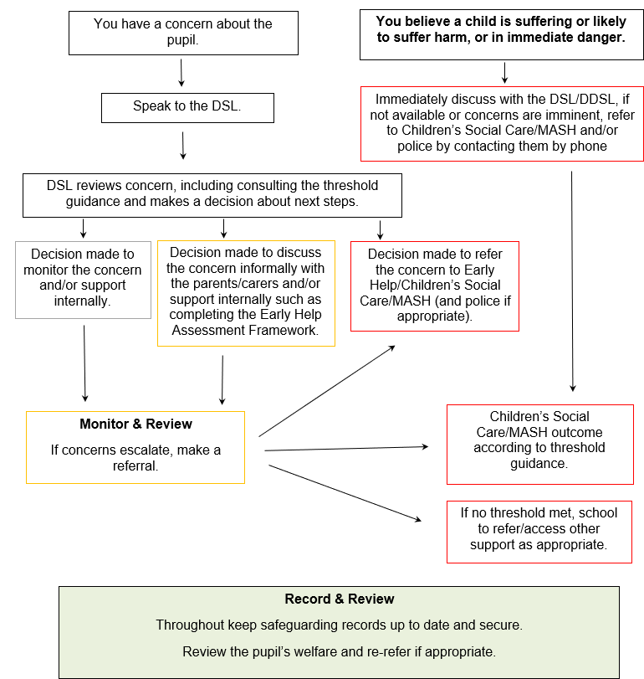
  - Concerns of a serious safeguarding nature or if there are concerns that the child is in immediate danger, this must be reported verbally and immediately to the DSL or DDSL’s.
  - Anybody can make a referral. Staff required to make a direct referral may find helpful the flowchart set out on page 24 of KCSIE.
  - Confirmation of the referral and details of the decision as to what course of action will be taken should be received from the local authority within one working day. If this is not received, the DSL (or the person that made the referral) should contact CSC again.
  - For any CYP who attend school and do not live in the same county as the Academy is located, then we will refer to the county that the child lives in.
  - If a referral is made by telephone, this should be followed up in writing.
  - If the referral is made by someone other than the DSL, the DSL should be informed of the referral and any actions taken as soon as possible.
  - Where the concern relates to the welfare of a pupil who is aged 18 or over, the DSL will consider whether it is necessary to refer such concerns to the Safeguarding Adults Board rather than, or in addition to, CSC.
  - Parental consent is not always required for referrals to statutory agencies, although it is best practice as long as it will not put the child at risk of harm.
  - All staff will consider the ‘big picture’ surrounding the child, including contextual safeguarding, and extra-familiar harm. Safeguarding incidents that take place externally to the school, if the school are made aware, these will be reported to the relevant service to provide the full context.
  - All staff understand that Child Criminal Exploitation (CCE) and Child Sexual Exploitation (CSE) are forms of child abuse and if we suspect a pupil is being exploited, we will respond immediately by contacting the Police and/or CSC.
  - As a school, we have an appointed Designated Teacher (a senior teaching staff member) and will work collaboratively with the Virtual School to improve the educational outcomes for these CYP by monitoring attendance, progress, and attainment, ensuring the Personal Education Plan’s (PEPs) are completed in a timely manner and meetings take place. The DT will act as an advocate for the Children Looked After (CLA) and Previously CLA (PCLA) and will also work with partners to raise aspirations for this cohort of CYP.
  - We will follow Resolving Professional Difference of Opinion and Escalation policy as necessary to ensure we can learn and understand the decision-making process of other agencies as well as challenge sensitively to ensure our pupil’s welfare and safety is paramount.
  - Our Plymouth LA referral procedure is outlined below: - MASH Contact (Referral to Children’s Social Care) - Plymouth Safeguarding Children Partnership and/or Plymouth City Council Children’s Services extending contact hours | PLYMOUTH.GOV.UK
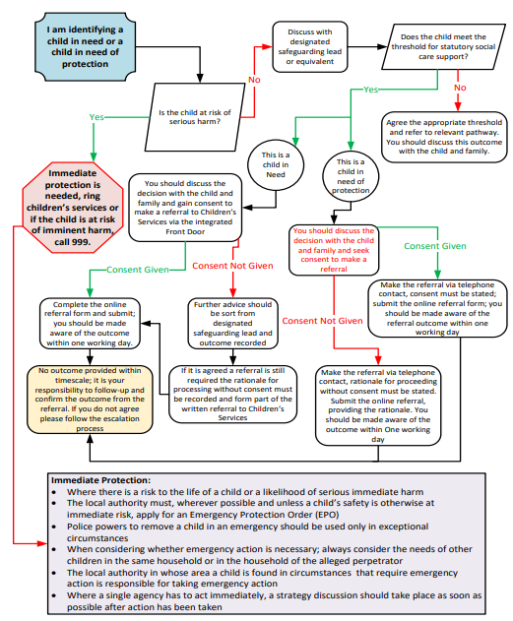

Female Genital Mutilation (FGM), Preventing Radicalisation and Mental Health
  - There is an FGM mandatory reporting duty for teachers Section 5B of the Female Genital Mutilation Act 2003 (as inserted by section 74 of the Serious Crime Act 2015). FGM is illegal in the UK and a form of child abuse.
  - The Prevent Duty (under section 26 of the Counter-Terrorism and Security Act 2015 (the CTSA 2015) requires schools to have due to regard to the need to prevent people from becoming terrorists or supporting terrorism, extremist ideology, and racialisation.
  - To support our compliance with the Prevent Duty we will complete the Prevent risk assessment annually Prevent duty: risk assessment templates - GOV.UK.
  - Schools have an important role to play in supporting the mental health and wellbeing of their pupils. Mental health problems can, in some cases, be an indicator that a child has suffered or is at risk of suffering abuse, neglect or exploitation.

FGM | Radicalisation | Mental Health
If you discover that FGM has taken place, or a pupil is at risk of FGM any teacher must immediately report this to the police, verbally by contacting 101. Following this, contact should then be made to CSC.  Unless they have been specifically told not to disclose, they should also discuss the case with the DSL and involve CSC as appropriate.  Any other member of staff who discovers that an act of FGM or is at risk of FGM must speak to the DSL and follow our local safeguarding procedure. | If there is an immediate threat, call 999.  If you have concerns that a pupil may be at risk of radicalisation, discuss this with the DSL immediately.  This may then include making a Prevent referral using the following information:  Plymouth:  Preventing Extremism | PLYMOUTH.GOV.UK  Prevent.referrals@devonandcornwall.pnn.police.uk | If you have a mental health concern about a pupil that is also a safeguarding concern and/or the wider safeguarding concern is further impacting on the pupil’s mental health, follow the “what to do when you are concerned about a CYP” procedure.  If you have a mental health concern that is not also a safeguarding concern, speak to the DSL to agree a course of action.

Alternative Provision (AP)

  - When a child attends an AP, we continue our lead responsibility for safeguarding and we will ensure our practices align with the Department for Education Guidance - Arranging Alternative Provision - guide for LAs and schools and LA procedures. We will ensure:
    - We are satisfied that the provision is safe and meets the child’s pastoral and educational needs, including at least half termly reviews to ascertain objectives are being met, the child is attending regularly, and the provision continues to be safe and meets the child’s needs.
    - Regular liaison with the alternative provision, child, parent/carer and LA will take place to monitor progress, attendance and well-being. Absence will be followed up promptly.
    - We will ensure we know the child is at all times, during school hours.

Out-of-School Settings

  - Where services or activities are provided separately by another body, we will complete our due diligence in line with keeping children safe in after-school clubs, community activities and tuition guidance [Link After-school clubs, community activities and tuition: safeguarding guidance for providers - GOV.UK] (also referred to as out-of-school settings including:
    - Making sure the provider has appropriate policies and procedures in place for safeguarding and child protection and that there are arrangements to liaise with the school on these matters where appropriate. This will be included in a lease/license or hire agreement, and any failure to comply would lead to termination of the agreement.
    - If we receive an allegation of an incident happening while an individual or organisation was using the school premises to run activities for CYP, we will follow our safeguarding policies and procedures and inform our LADO.
    - The governing body will seek assurances that the provider concerned meets these requirements set out in KCSIE and out-of-school settings guidance.

Attendance

  - We will closely monitor the attendance of all our CYP in a continuum for example, those that are absent from school, those with unexplainable absences and/or those children persistently/severely absent from education. Please see our Attendance Policies for more information, which is line with the following guidance Working together to improve school attendance - GOV.UK.
  - When a child is missing from education, the school will follow our LA procedures which includes referring to Mel Yowman.
We are working hard to improve attendance across the trust, here are our strategies for improving attendance. Strategies for improving school attendance.docx
  - For those CYP who have a social worker and/or a youth justice worker, if there are any unauthorised absences, suspensions, or a potential of a permanent exclusion we will inform CSC and any other professionals, as appropriate.

Risk Assessment
  - Where a concern about a pupil's welfare is identified, the risks to that pupil's welfare will be assessed and appropriate action will be taken to reduce the risks identified.
  - The format of risk assessment may vary and may be included as part of the Academy's overall response to a welfare issue, including the use of individual pupil welfare plans (such as behaviour, healthcare and education plans, as appropriate). Regardless of the form used, the Academy's approach to promoting pupil welfare will be systematic and pupil focused.
  - The [Headteacher] has overall responsibility for ensuring that matters which affect pupil welfare are adequately risk assessed and for ensuring that the relevant findings are implemented, monitored and evaluated.
  - Day to day responsibility to carry out risk assessments under this policy will be delegated to the DSL who has been properly trained in, and tasked with, carrying out the particular assessment.

Supporting Disclosures:

  - Training is provided to staff to support them when responding to a safeguarding concern.
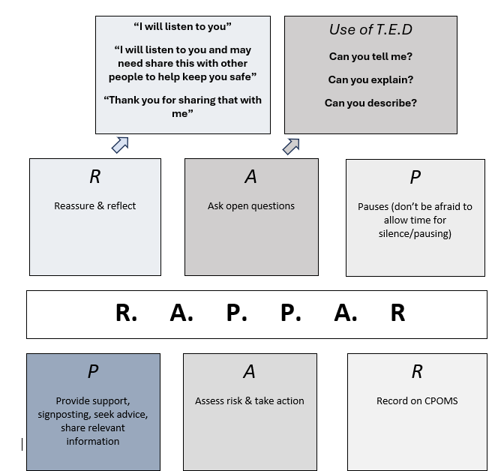
  - An overview of the general principles is set out below:
  - Staff understand they are unable to promise full confidentiality and will explain to CYP the reasons they will need to pass on information.
  - Staff at all times, will listen carefully and will not make a decision as to whether abuse, neglect, exploitation or any other safeguarding incident has taken place but will ensure they are supportive and reassuring to the child/ren.

Communication with Parents/Carers

  - When working with parents/carers, our approach will be in line with the four principles set out in Chapter one of the statutory guidance: Working Together to Safeguard Children 2023. In summary our priorities are:
    - Child-Centred Approach: The child's needs must always come first. Parents and carers should be involved in safeguarding processes, but the primary focus is on the safety and wellbeing of the child.
    - Partnership and Collaboration: We will work in partnership with parents and carers, valuing their input and aiming for open, honest, and respectful communication, while also recognising the limits of confidentiality when a child is at risk.
    - Transparency and Honesty: We will be clear and open with families about concerns, the reasons for involvement, and what will happen next, unless doing so would place the child at greater risk.
    - Respect for Diversity: We will treat parents and carers with respect, taking into account their culture, background, and individual circumstances, without making assumptions or being discriminatory.
  - In addition to the above we will:
    - Ensure that parents/carers are informed of the responsibility placed on the school and staff in relation to child protection.
    - Where appropriate, communication with parents/carers prior to involvement of another agency will take place unless the circumstances preclude this action. If the school believes that notifying parents/carers could increase the risk to the child or exacerbate the situation, advice will be sought from CSC.
    - Regularly communicate key safeguarding education relevant to parents/carers, including how to support their child in being safe at school, in the community and online. We will also make them aware of our filtering and monitoring systems.
    - Take into consideration when working with parents/carers the DfE guidance Understanding and dealing with issues relating to parental responsibility - GOV.UK

Safeguarding Interventions Including Early Help

  - We understand that we will be required to complete statutory referrals and in addition and as part of our role within a multi-agency response, we may need to be the lead professional in some safeguarding cases. We will collaborate with key partners and support may have to come directly from the Academy to support the welfare of CYP in our care.

  - All staff have regular training and support from the DSL to identify CYP who may benefit from early help. Early help means providing support as soon as a problem emerges at any point in a child’s life, from the foundation years through to the teenage years.
  - Early Help may be an appropriate intervention, that can be run internally or externally such as via the Local Authority. Our Early Help provision includes the Early Help Offer mentioned above and includes a range of therapeutic approaches, SEND specific support, and a range of pupil centred and/or family centred options. This is available prior to local authority support, which can be viewed below.
  - Our Plymouth Local Authority Early Help procedure can be found at Early help Plymouth; this includes information available to parent/carers, information for CYP with SEND, what the early support process is and how to complete and early support assessment form, once consent has been sought from the parent/carer.

Record Keeping
  - We will keep accurate, written safeguarding records on CPOMS (noting the date, location, details of the concern/incident), details of how the concern was followed up and resolved, actions taken, the decision reached, the rationale for decision making, and the outcome.
  - Discussions with colleagues and external stakeholders will be recorded.
  - We will ensure concerns and referral records are kept securely, in a separate child protection file for each child.
  - Records will also include a clear summary of the current and historic safeguarding concern(s) as well as a full chronology.
  - These records include details of all referrals and involvement including as a minimum, from CSC, the Youth Justice Team, and Early Help (regardless of the outcome of these referrals).
  - When recording incidents or actions on CPOMS, staff should ensure that records are:
- Professional (consider spelling and grammar, avoiding jargon, initials and abbreviations)
- Objective (be descriptive, use body maps and avoid subjective words (e.g., “inappropriate”)
- Accurate (avoid vague or ambiguous statements, distinguish between fact and opinion and use the child’s own words)
- Child Centred (capture the perspectives, wishes and feelings of the child, wherever possible)
- Timely (concerns should be logged at the earliest opportunity and within 24 hours)
- Succinct (details should be comprehensive, but concise)
- Evidenced (upload relevant evidence to the incident, such as statements, if applicable)
- Evidence of indecent images or videos of children MUST NOT be uploaded to CPOMS.
- Action focused (include any action already taken)

Confidentiality and Information Sharing
  - We recognise that the Data Protection Act (DPA) 2018 and UK GDPR does not prevent, or limit, the sharing of information for the purposes of keeping children safe and that timely information sharing is essential to effective safeguarding. The Academy has published on its website privacy notices which explain how the Academy will use personal data. All records created in accordance with this policy are managed in accordance with the Academy's policies that apply to the retention and destruction of records.
  - We will ensure that our confidentiality protocols are in line with the following guidance: For organisations | ICO and DfE non statutory information sharing advice for practitioners providing safeguarding services for children, young people,parents and carers (publishing.service.gov.uk).
  - Child protection records are normally exempt from the disclosure provisions of the Data Protection Act, which means that children and parents/carers do not have an automatic right to see them. If any member of staff receives a request from a pupil or parents/carers to see child protection records, they will refer the request to the DSL or Headteacher.
  - We will ensure that the information is only shared on a ‘need to know’ basis, including Domestic Abuse notifications and Operation Encompass. Operation Encompass supports communication between the Police and School regarding where a child has experienced a domestic abuse incident, ensuring that as a school we are able to put in place support for the child, as appropriate.
  - The relevant child protection records are sent to the receiving school or establishment (within 5 days for an in-year transfer or within the first 5 days of the start of a new term when a pupil moves schools). These will be sent securely and separately from the main pupil file, and a confirmation receipt will be obtained.
  - In all cases of sharing information, we take into consideration sharing only the information that is necessary, proportionate for the intended purpose, relevant, adequate, and accurate.

Child-on-Child Abuse

  - Our zero-tolerance approach to any form of child-on-child abuse is supported by our pastoral curriculum, PSHE curriculum, behaviour policy and our commitment to creating a supportive environment to minimise the risk of child-on-child abuse.
  - All staff recognise that children can abuse their peers (both online and offline) including, bullying, abuse in intimate personal relationships between children, physical abuse, sexual abuse, sexual violence and harassment, consensual and non-consensual sharing of nude and semi-nude images and/or videos, upskirting, initiation/hazing type violence and rituals.
  - We recognise that some groups are potentially more at risk. Evidence shows that girls, children with special educational needs and disabilities (SEND), and children who are lesbian, gay, bisexual, or questioning their gender are at greater risk. Pupils with SEND or certain health conditions can face additional safeguarding challenges and are 3 times more likely to be abused than their peers.
  - Safeguarding concerns involving CYP with SEND will require close liaison with the DSL and/or DDSL and the SENCo.
  - Staff are aware that even if there are no reports of child-on-child abuse in school, it does not mean it is not happening – staff should maintain an attitude of “it could happen here”.
  - If a concern is raised relating to the nudes/semi nudes, we will respond in accordance with Sharing nudes and semi-nudes: advice for education settings working with children and young people - GOV.UK (www.gov.uk).

Sexual Violence, Sexual Harassment and Harmful Sexual Behaviour

  - We will respond appropriately to all reports and concerns about sexual violence and/or sexual harassment both online and offline, including those that have happened outside of the school/college. We are clear that sexual abuse, violence, and harassment is not acceptable, and will never be tolerated and is not an inevitable part of growing up.
  - Whilst any report of sexual violence or sexual harassment should be taken seriously, staff are aware it is more likely that girls will be the victims of sexual violence and sexual harassment and more likely it will be perpetrated by boys.
  - We will follow the procedure on “what to do when you are concerned about a CYP” procedure, but we will ensure in all cases:
    - The DSL is informed and will have due regard for Part 5 of KCSIE and the local response of the police and CSC with these matters.
    - All staff understand and will challenge inappropriate behaviour between CYP.
    - Our response to child-on-child abuse will be immediate and supportive for all involved, and we will work with key agencies if appropriate to mitigate any further risks (such as; parents/carers, Police, CSC).
    - Each child(ren) views will be taken into consideration.
    - All those involved in such allegations will be treated as being at risk and in need of support, and in some cases a risk assessment will be developed. Appropriate support (internal and/or external) will be offered to all CYP involved.
    - Harmful Sexual Behaviour (HSB), child-on-child sexual abuse, violence or harassment cases will be consulted with CSC.

Online Safety

  - Our approach to online safety is based on addressing the four categories of risk:
- Content – being exposed to illegal, inappropriate, or harmful content, such as pornography, fake news, racism, misogyny, self-harm, suicide, antisemitism, radicalisation, and extremism.
- Contact – being subjected to harmful online interaction with other users, such as peer-to-peer pressure, commercial advertising and adults posing as children or young adults with the intention to groom or exploit them for sexual, criminal, financial or other purposes.
- Conduct – personal online behaviour that increases the likelihood of, or causes, harm, such as making, sending and receiving explicit images (e.g., consensual and non-consensual sharing of nudes and semi-nudes and/or pornography), sharing other explicit images and online bullying; and
- Commerce – risks such as online gambling, inappropriate advertising, phishing and/or financial scams
  - We recognise the importance of safeguarding CYP from potentially harmful and inappropriate online material, and we understand that technology is a significant component in many safeguarding and wellbeing issues.
  - Regular online safety training and dissemination of information, including about our online filtering and monitoring systems takes place for staff, CYP, and parents/carers.
  - If staff have safeguarding concerns linked with online safety and/or filtering and monitoring, they must report these to the DSL promptly.
  - The Academy has ensured appropriate filters and monitoring systems are in place and meet the DfE's filtering and monitoring standards (see the Online safety policy) and is mindful that this should not lead to unnecessary restrictions on learning.
  - We will also complete annual the London Grid for Learning OS Audit - Online Safety Audit from LGfL | LGFL.

Use of Mobile Technology

  - All practices within EYFS are in-line with the EYFS Statutory Framework and our mobile technology policies. Mobile phones and camera devices are not to be used to take digital media within the setting, without the express permission of the Headteacher or a Senior Leader in their absence. - Personal devices should be stored, secured in cupboards/drawers and not out within the setting; In areas where intimate care takes place, no digital devices are permitted at any time.
  - All staff should use mobile devices and cameras in accordance with the guidance set out in the staff Appropriate Workplace Behaviour Policy.
  - Parents of all CYP (including parents in the EYFS setting) may bring mobile devices onto the premises but may only take photographs during events such as plays, concerts or sporting events for personal use. Parents should be reminded that the publication of such images (including on personal social networking sites even where access to the image may be limited) may be unlawful.
  - The Academy allows access to the internet onsite. Appropriate internet safety measures are taken to manage associated risks, including use of filters and monitoring of usage. Visitors are able to connect to the internet using the network RSAT Guest Wireless. A password is available upon request.
  - The Academy's approach to online safety is set out in the Academy's Online safety policy and Acceptable use policy for pupils.
  - The Academy's policy on the use of mobile technology, including phones and cameras, in the Academy, is as follows:
    - The Academy's Acceptable use policy for CYP sets out the expectations from EYFS to Year 6 download.asp
    - Safer Recruitment, Allegations Against Staff and Low-Level Concerns

  - We will operate safer recruitment practices including ensuring appropriate DBS, identity checks and reference checks for all staff and volunteers and this is appropriately recorded on the Single Central Record.
  - Staff connected to the Academy's early years provisions are under an ongoing duty to inform the Academy if their circumstances change which would mean they meet any of the criteria for disqualification under the Childcare Act 2006.
  - The Academy has a specific Allegations Against Staff and Low-Level Concerns Policy. These procedures aim to strike a balance between the need to protect CYP from abuse and the need to protect staff from malicious, unfounded, false or unsubstantiated allegations. The policy and procedures are set out in the Allegations Against Staff and Low-Level Concerns Policies and the guidance in Part 1, 3 and 4 of KCSIE.
  - All staff are aware that they must report any concern or allegation about a member of staff, including supply staff, volunteers, contractors and out-of-school setting providers, or any other adult, including those that may not meet the threshold.
  - We embed a culture of openness, trust, and transparency in which the school’s values and expected behaviour set out in the Appropriate Workplace Behaviour Policy and are lived, monitored, and reinforced constantly by all staff.
  - Detailed guidance is provided to staff to ensure that all staff are clear on the rules of conduct and the expectations of the Academy in relation to contact with pupils, parents, colleagues and any other person who comes into contact with the Academy. This guidance is contained in the Appropriate Workplace Behaviour Policy and includes details of additional safeguarding arrangements where staff engage in one-to-one teaching and meetings with pupils.
  - Staff may follow the Academy's Whistleblowing Policy to raise concerns about poor or unsafe safeguarding practices at the Academy or potential failures by the Academy or its staff to properly fulfil its safeguarding responsibilities. Such concerns will be taken seriously. The NSPCC whistleblowing helpline is available for staff who do not feel able to raise concerns about child protection failures internally (see the front of this policy for the relevant contact details). Staff may also report concerns direct to the Academy's Local Authority or to the ESFA if they consider that the Academy has failed to deal with concerns appropriately.

Site Security

  - Additional Safer Recruitment procedures are set out in the separate Single Central Record Safer Recruitment Guidance for Visitors & Employees.
  - Visitors are asked to sign in at the school reception If visitors have undergone the appropriate checks, they can be provided with unescorted access to the school site and must wear a green lanyard at all times. Visitors who have not undergone the required checks will be escorted at all times and must wear a red lanyard.
  - The Academy will follow its employment procedures for dealing with any other safeguarding concern raised about staff, involving external agencies as appropriate.

Additional Reporting

  - What to do if staff have a safeguarding concern about someone else’s welfare:
    - Staff who have safeguarding concerns about the welfare of others or any other safeguarding issue not expressly covered by this policy, should report them.
    - In the absence of an express procedure about reporting, they should report such concerns to their line manager or the DSL in the first instance.
  - Health and Safety Executive: The Academy is legally required under RIDDOR to report certain incidents to the Health and Safety Executive. Please see the Academy's Health and safety policy for further details about this.
  - Education and Skills Funding Agency (ESFA): The Academy Trust is an exempt charity and is required to report all serious incidents to the ESFA promptly and in accordance with the guidance How to report a serious incident in your charity (Charity Commission, June 2019) includes examples of incidents it may be necessary to report.
  - Disclosure and Barring Service (DBS): A referral to the DBS will be made promptly if the criteria are met. See Reach South Academy Trust DBS Policy.
  - Teaching Regulation Agency (TRA): Separate consideration will be given as to whether a referral to the TRA should be made where a teacher has been dismissed, or would have been dismissed if they had not resigned.
  - Ofsted [EYFS Only]: The Academy will inform Ofsted of any allegations of serious harm or abuse by any person living, working or looking after children on the premises of the EYFS provision registered with Ofsted (whether that allegation relates to harm or abuse committed on the premises or elsewhere), and will provide details of the action taken in respect of those allegations.
  - Insurers:
    - The Board of Trustees will consider whether it is necessary to report a safeguarding incident to the relevant insurers and / or brokers. It may be necessary to report to a number of insurers as there may be concurrent cover under existing and historic policies.
    - Care should be taken to ensure this is done before renewal to ensure that the Board of Trustees complies with its duties under the Insurance Act 2015. If the Board of Trustees is in any doubt with regard to the correct insurer and / or policy and / or if it is unable to locate the relevant insurer, professional advice should be sought.

Policy History
Date | Summary of change | Contact
09/10/2023 | New Policy | Emma Twell
16/09/2024 | Policy Updated | Debbie Innes-Turnill
20/05/2025 | Policy Reviewed and Updated | Sharna Denver

Appendix 1

Abuse, Neglect and Exploitation (extracted from Keeping Children Safe in Education (2024)
Abuse is a form of maltreatment of a child. Somebody may abuse or neglect a child by inflicting harm or by failing to act to prevent harm. Harm can include ill treatment that is not physical as well as the impact of witnessing ill treatment of others. This can be particularly relevant, for example, in relation to the impact on children of all forms of domestic abuse, including where they see, hear, or experience its effects. Children may be abused in a family or in an institutional or community setting by those known to them or, more rarely, by others. Abuse can take place wholly online, or technology may be used to facilitate offline abuse. Children may be abused by an adult or adults or by another child or children.

Physical abuse: a form of abuse which may involve hitting, shaking, throwing, poisoning, burning or scalding, drowning, suffocating or otherwise causing physical harm to a child. Physical harm may also be caused when a parent or carer fabricates the symptoms of, or deliberately induces, illness in a child.

Emotional abuse: the persistent emotional maltreatment of a child such as to cause severe and adverse effects on the child’s emotional development. It may involve conveying to a child that they are worthless or unloved, inadequate, or valued only insofar as they meet the needs of another person. It may include not giving the child opportunities to express their views, deliberately silencing them or ‘making fun’ of what they say or how they communicate. It may feature age or developmentally inappropriate expectations being imposed on children. These may include interactions that are beyond a child’s developmental capability as well as overprotection and limitation of exploration and learning or preventing the child from participating in normal social interaction. It may involve seeing or hearing the ill-treatment of another. It may involve serious bullying (including cyberbullying), causing children frequently to feel frightened or in danger, or the exploitation or corruption of children. Some level of emotional abuse is involved in all types of maltreatment of a child, although it may occur alone.

Sexual abuse: involves forcing or enticing a child or young person to take part in sexual activities, not necessarily involving violence, whether or not the child is aware of what is happening. The activities may involve physical contact, including assault by penetration (for example rape or oral sex) or non-penetrative acts such as masturbation, kissing, rubbing, and touching outside of clothing. They may also include non-contact activities, such as involving children in looking at, or in the production of, sexual images, watching sexual activities, encouraging children to behave in sexually inappropriate ways, or grooming a child in preparation for abuse. Sexual abuse can take place online, and technology can be used to facilitate offline abuse. Sexual abuse is not solely perpetrated by adult males. Women can also commit acts of sexual abuse, as can other children. The sexual abuse of children by other children is a specific safeguarding issue in education and all staff should be aware of it and of their school or college’s policy and procedures for dealing with it.

Neglect: the persistent failure to meet a child’s basic physical and/or psychological needs, likely to result in the serious impairment of the child’s health or development. Neglect may occur during pregnancy, for example, as a result of maternal substance abuse. Once a child is born, neglect may involve a parent or carer failing to: provide adequate food, clothing and shelter (including exclusion from home or abandonment); protect a child from physical and emotional harm or danger; ensure adequate supervision (including the use of inadequate care-givers); or ensure access to appropriate medical care or treatment. It may also include neglect of, or unresponsiveness to, a child’s basic emotional needs.

Child Criminal Exploitation (CCE) and Child Sexual Exploitation (CSE): Forms of abuse that occur where an individual or group takes advantage of an imbalance in power to coerce, manipulate or deceive a child into taking part in criminal or sexual activity. It may involve an exchange for something the victim needs or wants, and/or for the financial advantage or increased status of the perpetrator or facilitator and/or through violence or the threat of violence. CCE and CSE can affect children, both male and female and can include children who have been moved (commonly referred to as trafficking) for the purpose of exploitation.

All staff are aware that CCE and CSE are forms of child abuse

Appendix 2

Additional Specific Safeguarding Issues (this is not an exhaustive list, please refer to Keeping Children Safe in Education, in particular Annex B).

- Bullying including cyber bullying
- Child abduction and community safety incidents
- Child Sexual Exploitation (CSE)
- Child Criminal Exploitation (CCE)
- Children and the court system
- Children missing from Education
- Children of substance misusing parents/carers
- County lines
- Domestic abuse
- Substance abuse
- Fabricated or induced illness
- Formal complaint policy
- Children with family members in prison
- Faith abuse
- Female Genital Mutilation (FGM)
- Forced Marriage Gangs and Youth Violence
- Gang Activity
- Gender based violence/violence against women and girls (VAWG)
- Hate crime
- Mental health
- Homelessness
- Health and well-being
- So called ‘Honour-based’ abuse
- Child-on-Child abuse
- Consensual and non-consensual sharing of indecent images/nude/semi-nude images/videos
- Sexual violence and sexual harassment between children in schools
- Private fostering
- Preventing radicalisation (The Prevent Duty)
- Online abuse including indecent images/nude/semi-nude images/videos
- Teenage relationship abuse
- Trafficking
- Missing children and vulnerable adults
- Child sexual abuse within the family
- Poor parenting, particularly in relation to babies and young children
- Serious violence
- Cyber crime



